AGENDA / MEETING MINUTES
59th Annual General Meeting of
Doncaster Rovers Soccer Club Incorporated
Anderson Park – 117 Andersons Creek Road Doncaster East
Saturday 25 ^{th} October 2025 at 2:30 pm

- Opening – Ruud van Henten (Secretary)
Meeting officially opened at 14:31hrs on 25th October 2025. The Doncaster Rovers Soccer Club has experienced remarkable growth in membership, financial stability, and community engagement. Despite challenges in the senior programs, the club has laid strong foundations for future success, supported by robust volunteerism, new sponsorships, and a commitment to youth and women’s football development.

- Quorum & apologies – Ruud van Henten (Secretary)
Quorum acknowledged (see attached attendance sheet) and proxy votes

Apologies: none received

- Minutes of the AGM for financial year 2024 held in February 2025.
- One comment: Item 13: Noted that General Committee role (MiniRoos coordinator) was elected for 1 year as it was a casual vacancy. The item was not handled by Nick Trimmatis (but John Stavretis).

Previous AGM (2024 minutes) adoptions:
  - Nicole Minster moves and accepts DRSC AGM 2024 Minutes
  - John Stavretis seconds to accept AGM 2024 minutes.

- Presidents Report – Jim Aspropotamitis
- Welcome life members and members for our 59th AGM, for season concluding 2025
- A thank you to our departing committee members, Jess Tedesco, John Stavretis and Nikki Aspropotamitis.

- A warm welcome to new in coming members and current existing members looking to go another term

- Season 2025 was a huge success in many ways. Growth in participation across mini, juniors and our VCFA programme. Our women's participation grew almost 400%, fielding our first senior women's team in 13 years. Our senior men had a challenging year, a change of coach, players and football re structure saw them finish bottom of the table and fall into state 3 for season 2026. Silvio to further elaborate in the senior's report.

- Revenue was up, largely due to increased player participation, canteen and fund raising throughout the year. The canteen broke new revenue records, a special thanks to all our volunteers who put in hours of work to make that happen.

- With revenue increase, we have been able re invested heavily in our Junior and Mini roos programme, by employing Nick Ansell as the TD. Nick will oversee over 300 kids, helping coaches with development and running programmes to best benefit teams and individuals. This started in October 2025, and will run for a 12-month duration, at which point we will assess. Further investment in new goals, balls, and basic equipment, gearing up for a bigger 2026. Nick has also started the NAFA academy, which has been incredibly well received, over 50 kids in the 3-day holiday programme, and over 100 kids involved in the term 4 programme.
- We have also appointed Silvio Santostefano as our Football Director for 2026. He will work closely with senior coach Loui and reserves coach Jim to help further enhance our pathway programme, from juniors to seniors. This year, we had 7 under 18s play reserve football, we look to continue that next year as those boys enter an under 21 side.
- We had record numbers of juniors helping coach and mentor our junior teams, for this we are so appreciative and thank all our junior coaches for participating in that programme.
- Our hard-working volunteers, team managers, coaches and all that lend a helping hand we are very grateful and appreciative of your time, and effort you put in throughout the year. Thank you from the committee, and all the club members.
- Our sponsors hit a record high, without your financial support and backing we cannot run the club as we do, for this we are so thankful for your support and belief in the club. Every cent you contribute goes back into our football development programmes, giving us the best opportunity to continue to deliver the best we can for all our members.
- Finally, to our hard working and dedicated committee I cannot thank you enough. Nicole our Vice President, Silvio our treasurer, Ruud our Secretary, John our registrar, Andrea our Junior co Ordinator, Bree our mini roos co Ordinator, Nikki, Mithra, Cathy and Jess, without you guys we cannot function. On behalf of the club and myself I cannot thank you enough.
- Congratulations again to everyone at the club who has had a hand in making 2025 such a successful season in so many ways .

- Treasurers Report – Silvio Santostefano (Treasurer)
Treasurers Report:

- Continued strong growth in Memberships, Sponsorship and Canteen has resulted in significant improvement in overall financial health
  - Non-football income buoyed by Election revenue from Hall Hire
- 2025 Surplus of $51k resulting from:
- * Canteen income up 30%
- * Membership up 50%
- * Sponsorship up 55%
- Improved financial health has enabled committee to clear the long-standing GST liability – we are now up to date with all ATO obligations
- Further $18k investment in Facilities & Equipment:
- * CCTV & Audio System
- * Sporting Equipment
- We have now recovered all prior period losses with a strong balance sheet

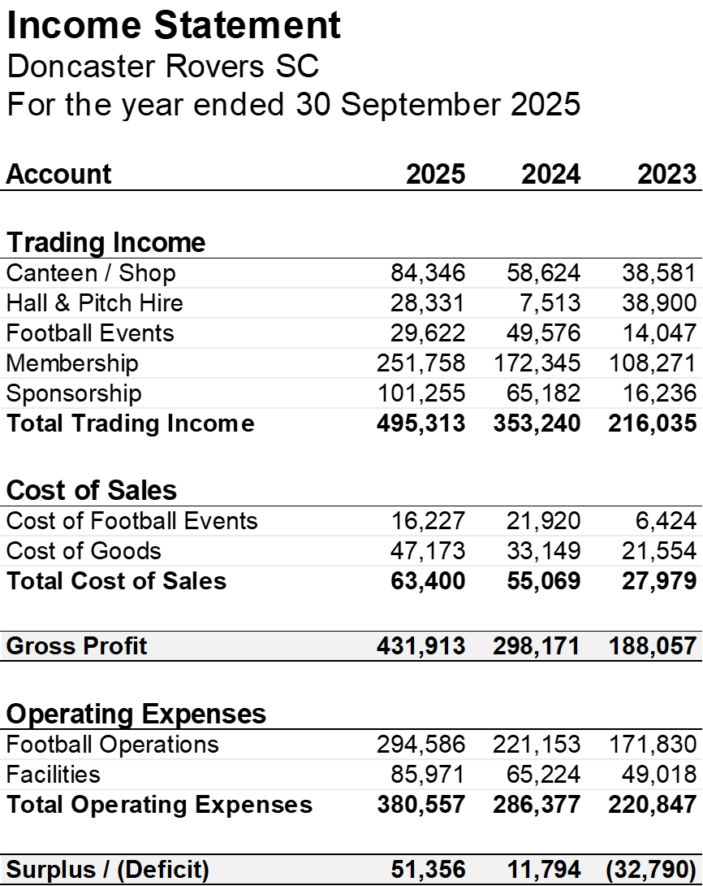

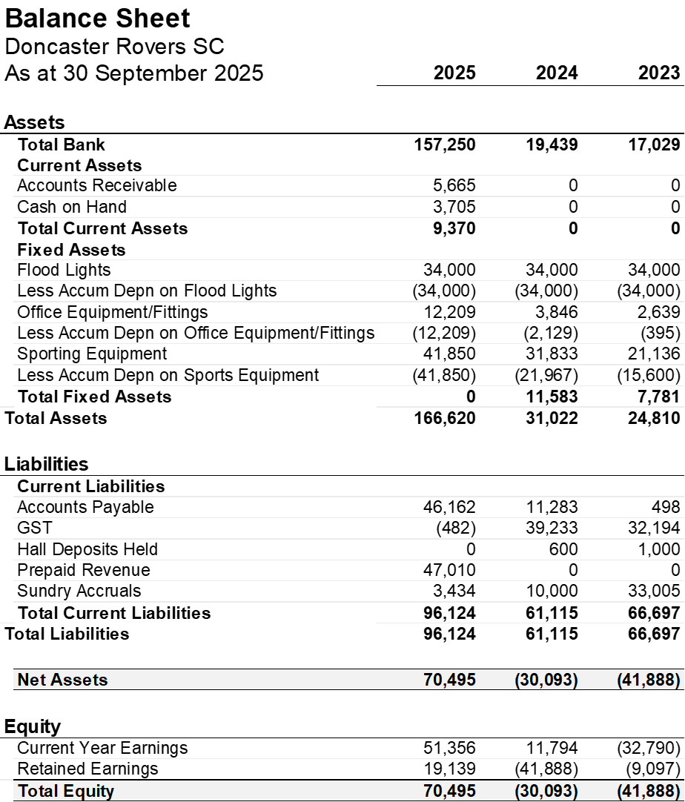
  - There was a discussion about payments to senior women: committee commented this was depending on which state league they would be playing (which was under discussion with FFV). Committee also mentioned that a sponsor will contribute to the senior men teams, guaranteeing funding for a period of 3 year.
  - Move and acceptance of treasures report – John Stavretis
  - Martine Sproule Carroll Seconds the move to accept.

- Senior men Report – Silvio Santostefano (Senior Coordinator)
- Very challenging and disruptive year for the Senior Men’s program which involved exit of coach and players early in the season
- This required a complete re-set for the program including a new coach/assistant, completely new playing style and an almost entirely new squad – a total of 41 players were used during the season (35% higher than average)
- These changes and disruption, coupled with an unfit, ill-prepared and inexperienced squad, proved insurmountable resulting in the team finishing last on the ladder and being relegated to State League 3 for the 2026 season
- We firmly believe we now have the solid foundation required together with the right culture, unity and “club first” attitude to grow the program – including resetting the amounts paid to players
- We are also creating the player pathway for juniors to be given exposure and opportunities to play with the seniors – with many players from U18s playing with Reserve men this year.

- Juniors Report – Jim Aspropotamitis presented on behalf of Andrea Jamieson (Junior/ Womens Coordinator)
- 2025 we had 11 teams (221 players) in Junior Boys/Mixed Competitions
- 1 x U12C Sayyad & Kobi
- 1 x U12D Billy & Hadi
- 1 x U13C Ahmed & Hamad
- 1 x U13C Chris & Ken
- 1 x U13C Dennis
- 1 x U14A Con & Cal
- 1 x U14C Stefano & Peter
- 1 x U15C Rob
- 1 x U16D Alessia
- 1 x U17C Leeam
- 1 x U18B Dugie
- U18s & U13 Ahmed both finished second in their leagues

- Women’s and Girls Report – Jim Aspropotamitis presented on behalf of Andrea Jamieson (Junior/Womens Coordinator)

- Senior Women:
- Our first Senior Women's team in 11 years.
- Coach: Jim Anastassiou
- Team Manager: Steve De Carlo
- Captain: Alessia De Carlo
- They finished 10th in State League 4

- 2025 we had growth in our all-female teams
- 1 x U8 Joeys Chloe, Jorja, Sienna
- 1x U11 Joeys John & Bill
- 1 x U15C Peter & Mark
- This is an increase from 1 Junior team in 2024.

- Mini-Roos Report Jim Aspropotamitis presented on behalf of Bree Fredericks (MiniRoos Coordinator)

- A fantastic 2025 season with 13 MiniRoos teams (up from 9 in 2024) and 153 players, (up from around 85 in 2024) — showing huge growth across the program!
- Age Group Summary –
• 2 × Under 7 teams
• 2 × Under 8 teams
• 3 × Under 9 teams
• 2 × Under 10 teams
• 4 × Under 11 teams – our biggest miniroos group yet!
- Participation Growth – Strong jump in player numbers and family engagement, highlighting how popular our Rovers Miniroos program has become in our community.
- Coaching & Development – Teams were supported by a coaching team of 27 parents, friends and older Rovers players coaches. We again increased the number of our junior players getting involved as coaches in our Miniroos competition — giving our Minis the chance to learn skills and be mentored by older club teammates, while also providing great development opportunities for the young coaches.

- VCFA Report –Emmanual Pythas (VCFA Coordinator)
2025 Season:
- Seventh year since the DRSC VCFA inception (2019)
- Encouraging growth with 2 new teams added - Over 40’s Masters & Div 4 Gladiators.
- 4 teams in total - 82 registered players; 85 games played between the teams; return to club by numerous DRSC VCFA foundation players.

2026 Season:
- MPL 2 Firsts & MPL 2 Reserves; Div 4 for Gladiators; Over 40’s Masters
- Pre-season training to start in Feb with trials & practice games to be arranged
- Season starts Apr 4 & ends Aug 22 (TBC). Optional pre-season cup in mid-Apr
- Players – 46 confirmed; 25 yet to commit; 8 not returning
- Aiming for squads of 20 players p/team. Player recruitment imperative
- 2-3 coaches needed
- DRSC VCFA welcomes pathway opportunity for DRSC FV players to participate with VCFA teams for more regular game time, during recovery or to stay fit.

- Council and maintenance report – Jim Aspropotamitis (President)
- We have been engaging regularly with council during season 2025 with regards to having our Friday night games back. As it currently stands, there is a 9pm curfew across all Manningham sporting fields, we are seeking a 1-hour extension to this policy so as to allow Senior and Reserve games back-to-back on Friday nights. We anticipate an answer late November.
- Due to a lack of funding, no grass pitches in Manningham are being re turfed, the council strategy for the off season is to allow them to rest and recover. The grounds will remain open for public use during this time. In January 2026, the grounds are handed back to the club, where arranged pre-season training can take place, as well as practice games. The club will be mindful in season 2026 to monitor training and usage on both pitches and try to minimize over usage.
- The master plan is on track for the 1st stage to take place in September 2026. The main pitch will go full synthetic, upgraded lighting, a roadway around the entire pitch, new playground area on the North side and a new $100,000 scoreboard to be built. The proposed schedule will have this 1st stage completed by the end of April, start of May. Some games re scheduling will need to take place in this early part of the season.
- The entire 1st stage investment is 3 million dollars, of which 2 million is currently allocated, with a further $500,000 being sought via a State Government grant, and a further $500,000 from our local council. Zac who is controlling the project is confident both will be granted.
- Stage 2 of the master plan to begin September 2027, planning and schedules are in place.

- Club Person of the year and Life Membership – Jim Aspropotamitis (President)
Club Person of the Year Nominee for Season 2025: Wesley Minster

Doncaster Rovers SC Constitution (2019) rules –Section 8 Patrons and Life Members: Nomination for life-membership in 2025: Michael Ivanusic.

  - Michael Ivanusic has been a member of Doncaster Rovers Soccer Club for over 50 years. His enduring support spans three generations of his family and reflects a deep commitment to the club’s values, community, and development. His contributions have been consistent, generous, and impactful across both sporting and cultural dimensions of the club.

Motion:
That Michael Ivanusic be awarded Life Membership of Doncaster Rovers Soccer Club in recognition of his outstanding service and long-standing contribution.

Moved by: Ruud van Henten
Seconded by: Jim Aspropotamitis

Members expressed strong support and appreciation for Michael’s legacy and ongoing involvement in the club.
Vote Outcome:
Carried by majority.

- Ratification and Election of Office Bearers and Committee Members – Ruud van Henten (Secretary)
Nominations:
  - Executive Roles:
    - President – Jim Aspropotamitis
    - Secretary – Ruud van Henten
  - General Committee Roles:
    - General Committee – Caterina D’Intini
    - General Committee – Andrea Jamieson (Furlan)
    - General Committee – Mithra Thuraisingam
    - General Committee – Emmanuel Pythas
    - General Committee – Bree Fredericks

  - Move to accept nominations as presented above – Anthony Moutafis
  - Seconded by – John Pellarini

- Constitution Amendments & Policy Updates – Ruud van Henten (Secretary)
Constitution Amendments:
- None proposed

- General Business – Ruud van Henten (Secretary)
John Stavretis Proposed to amend the club’s child safety policy to require annual police checks for volunteers, aligning with updated standards. The committee acknowledged the proposal and will consider this in the next committee meeting.

- Close – Ruud van Henten (Secretary).
- DRSC AGM 2025 officially closed @ 15:27hrs by Ruud van Henten.

