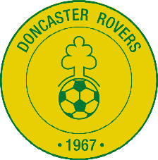

AGENDA
59th Annual General Meeting of
Doncaster Rovers Soccer Club Incorporated
Anderson Park – 117 Andersons Creek Road Doncaster East
Saturday 25th of October 2025 at 2:30pm

- Opening –
- Quorum and Apologies -
- Minutes of the AGM held in February 2025 –
- Presidents Report –
- Treasurers Report –
- Senior men Report –
- Women’s and girls’ Report
- Juniors Report –
- MiniRoos Report –
- VCFA Report -
- Council and Maintenance Report –
- Club person of the year and Life Membership–
- Ratification and Election of Office Bearers and Committee Members –
- Constitution amendments and Policy updates
- General Business –
- Close –

